Pupil premium strategy statement – Boston St Mary’s RC Primary Academy 2025-26

This statement details our school’s use of pupil premium funding to help improve the attainment of our disadvantaged pupils.
It outlines our pupil premium strategy, how we intend to spend the funding in this academic year and the outcomes for disadvantaged pupils last academic year.

School overview
Detail | Data
Number of pupils in school | 189
Proportion (%) of pupil premium eligible pupils | Number and %
Academic year/years that our current pupil premium strategy plan covers (3-year plans are recommended – you must still publish an updated statement each academic year) | 2025-26 to 2027-28
Date this statement was published | December 2025
Date on which it will be reviewed | December 2026
Statement authorised by | L.Gleed-Thornley, Headteacher
Pupil premium lead | M.Brader
Governor / Trustee lead | M.Lewis

Funding overview
Detail | Amount
Pupil premium funding allocation this academic year | £46925
Pupil premium funding carried forward from previous years (enter £0 if not applicable) | £0
Total budget for this academic year | £ £46925

Part A: Pupil premium strategy plan

Statement of intent
At Saint Mary’s, the focus of our Pupil Premium Strategy intention is that; for all children regardless of their needs have access to outstanding quality teaching and learning tailored to their needs. Through our Pupil Premium strategy, we are committed to ensuring disadvantaged pupils thrive academically, spiritually and personally, including those who are already high attainers.

‘United in Christ, One Family in God’s Heart’

Our mission at Saint Mary’s is to equip all children with knowledge, skills, experiences, and understanding, they need to thrive at each stage of their education and beyond. We recognise the unique barriers faced by vulnerable pupils and will work relentlessly to remove obstacles that hinder their learning journey. At centre of our approach is outstanding quality teaching and learning, this has been proven to have the greatest impact on closing the disadvantage attainment gap and at the same time will benefit the non-disadvantaged pupils in our school.

At Saint Mary’s our approach is responsive to common challenges and individual needs, rooted in robust diagnostic assessment, not assumptions about the impact of disadvantage. The approaches we have adopted complement each other to help pupils excel.

To ensure they are effective we will:
Challenge disadvantaged pupils through ambitious, high-quality learning
Act early to intervene at the point need is identified
Adopt a whole school culture of responsibility and high expectations where all members of staff support the outcomes of disadvantaged pupils’ outcomes and raise expectations of what they can achieve.
Pupil Premium funding will be allocated following a needs analysis which will identify priority classes, groups or individuals. The grant is aimed at accelerating progress by moving children to at least age-related expectations. We aim for all pupils to make good progress and achieve high attainment across all subject areas.
These pupils may require additional support, so we will use all the resources available to help them reach their full potential including the Pupil Premium Grant. Staff are committed to meet pupils’ needs, including their pastoral, social and academic needs within a caring and nurturing environment. It is important for disadvantaged children to benefit from the same opportunities as pupils from less deprived families.
In making provision for socially disadvantaged pupils, we recognise that not all pupils who receive free school meals will be socially disadvantaged. We also recognise that not all pupils who are socially disadvantaged are registered or qualify for free school meals. We reserve the right to allocate the Pupil Premium funding to support any pupil or groups of pupils the school has legitimately identified as being socially disadvantaged. Limited funding and resources mean that not all children receiving funding will be in receipt of pupil premium interventions at one time.

Challenges
This details the key challenges to achievement that we have identified among our disadvantaged pupils.
Challenge number | Detail of challenge
1 | Attendance of disadvantaged pupils has been % lower than for no disadvantaged pupils  % of disadvantaged pupils have been ‘persistently absent’ compared to % of non-disadvantaged pupils in this time period.
2 | Attainment of children in Maths and English (including Phonics, reading and writing)
3 | Lack of enrichment opportunities outside of school due to the poor socio-economic  climate.
4 | Complex family issues, which have a negative impact on the emotional needs and wellbeing of the children.
5 | Challenges in home lives make it difficult for carers and parents to support children in their learning at home such as English as an additional Language.
6 | Low income of some families, not classes as Pupil Premium

Intended outcomes
This explains the outcomes we are aiming for by the end of our current strategy plan, and how we will measure whether they have been achieved.
Intended outcome | Success criteria
To achieve and sustain improved attendance for all pupils, particularly our disadvantaged pupils. | Sustained high attendance from 2025/26 demonstrated by:  • the overall persistent absence rate for all pupils being no more than 10%, and the attendance gap between disadvantaged pupils and their non-disadvantaged peers being minimal.
To raise achievements among disadvantaged pupils in all reading, writing and maths. | All children have access to quality  teaching.  All children will make progress regardless of their background or vulnerabilities.  The gap between FSM and non-FSM will get smaller.
Provide enrichment activities to close the socio-ecomomic gap outside of the classroom and encourage wider cultural capital. | Children will be increasingly engaged in their learning through access of different workshops and visitors which reflects the broad and balanced curriculum.
Provide pastoral support to children and their mental health. This ensures that no learning is lost and experiencing difficult personal circumstances. | Children will feel safe, secure and build up their resilience.  Children will be able to overcome mental health or wellbeing struggles to work towards mental wellness.  Access to our Emotional Literacy Support Assistant (ELSA) and our Mental Health Support Team (MHST).

Activity in this academic year
This details how we intend to spend our pupil premium funding this academic year to address the challenges listed above.

Teaching (for example, CPD, recruitment and retention)
Budgeted cost: £29,578
Activity | Evidence that supports this approach | Challenge number(s) addressed
Sustaining high quality first teaching in  reading,  writing  mathematics  to improve outcomes for pupils  •CPD – effective CPD to address the issues identified within the School Improvement Plan  •CPD for NELI and WellComm for targeted staff | Ofsted Mathematic Subject Review  Ensuring pupils have the basic knowledge at their fingertips will best equip them for maths mastery approaches  EEF-Effective Professional Development Guidance Report  - shows that what happens in the classroom makes the biggest difference to children’s progress – improving teaching quality generally leads to greater improvements at lower cost than structural changes.  There is particularly good evidence around the potential impact of teacher professional development. Good teaching for all pupils has a particular benefit for disadvantaged pupils. | 2
To improve KS1 PP pupils’ ability in phonics & reading fluency; phonological awareness and letter sound knowledge, oral blending, sight reading of phonetically irregular words, their ability to read fluently. | EEF-Effective Professional Development Guidance Report  EEF –Phonics | 2
Embed communication and language approaches across the curriculum to improve spoken language skills, expressive vocabulary. | EEF – Communication and language approaches | 2
DfE validated Systematic Synthetic Phonics programme Read Write Inc | EEF –Phonics | 2

Targeted academic support (for example, tutoring, one-to-one support, structured interventions)
Budgeted cost: £ 7500
Activity | Evidence that supports this approach | Challenge number(s) addressed
One to one support for PP pupils to narrow the gap in maths – focus on fluency and number acquisition | EEF – Small group tuition  EEF – one to one tuition | 2
One to one support for PP pupils to narrow the gap in reading | EEF – Small group tuition  EEF – one to one tuition | 2
Additional phonics sessions targeted for disadvantaged pupils who require further phonics support. | EEF – Small group tuition  EEF – one to one tuition  EEF – Phonics | 2
ESLA Support for vulnerable learners/PP/SEND | EEF – Emotional and Emotional Learning | 1, 2,3,4

Wider strategies (for example, related to attendance, behaviour, wellbeing)
Budgeted cost: £ 9884
Activity | Evidence that supports this approach | Challenge number(s) addressed
Staff trained in Child Mental Health  Child Mental Health Ambassador  ELSA support for most vulnerable pupils | EEF – Emotional and Emotional Learning | 1,4,5
To provide targeted support around well-being and mental health for our disadvantaged pupils  Lunchtime activities to provide high quality games and activities to engage pupils | EEF – Emotional and Emotional Learning | 1,4,5
Subsidies for uniforms, equipment, clubs, trips, events and wraparound provision for our most vulnerable pupils  Access to learn to play an instrument (piano, violin) | EEF – Emotional and Emotional Learning  EEF – Arts Participation  Participation in after-school clubs can enhance involvement opportunities, resilience and confidence. EEF research states that essential life skills or character development are important in determining life chances | 6
Supporting pupil outcomes through enrichment activities and life skills | EEF – Emotional and Emotional Learning | 2,3,4
Attendance support.  Attendance letters & communication with parents  First day calling and  attendance meetings  with parents for Pas. | DFE school attendance framework.  EEF Working with Parents to Support Children’s Learning  Evidence suggests that effective parental engagement can lead to learning gains. | 1
Contingency fund for acute issues. | Based on our experiences and those of similar schools to ours, we have identified a need to set a small amount of funding aside to respond quickly to needs that have not yet been identified. | All challenge areas dependent upon need

Total budgeted cost: £

Part B: Review of the previous academic year

Outcomes for disadvantaged pupils
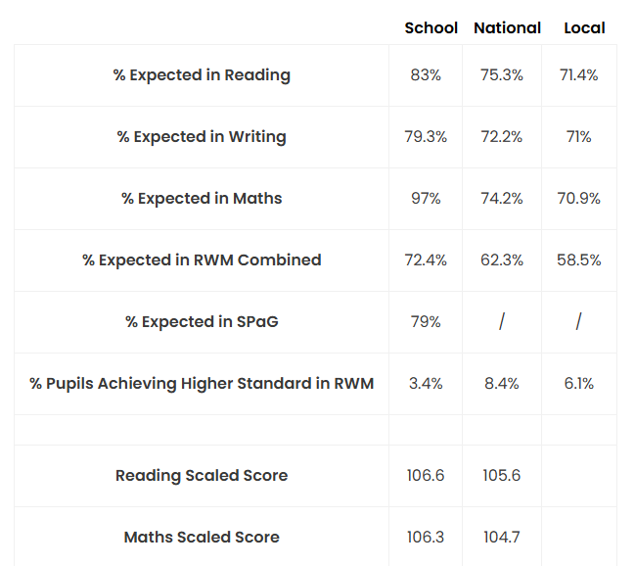
KS2 SATs Results

Y4 MTC: The percentage of pupils achieving full marks (25 out of 25) is 19.3% and the mean score of the school is 19.2.
PSC: The percentage of children achieving the Phonics threshold at school for 2024/25 was 79.3% and nationally the percentage was 79.9%
EYFS GLD: The percentage of children reaching a Good Level of Development at school for 2024/25 was 65%, locally was 66.4% and nationally was 68.3%

Externally provided programmes
Please include the names of any non-DfE programmes that you used your pupil premium to fund in the previous academic year.
Programme | Provider
TT Rockstars | https://ttrockstars.com/
Charanga Music | https://charanga.com/site/
Accelerated Reader | https://www.renaissance.com/
NELI | Oxford Education
Wellcomm | GL Assessment
Langauge for Thinking

