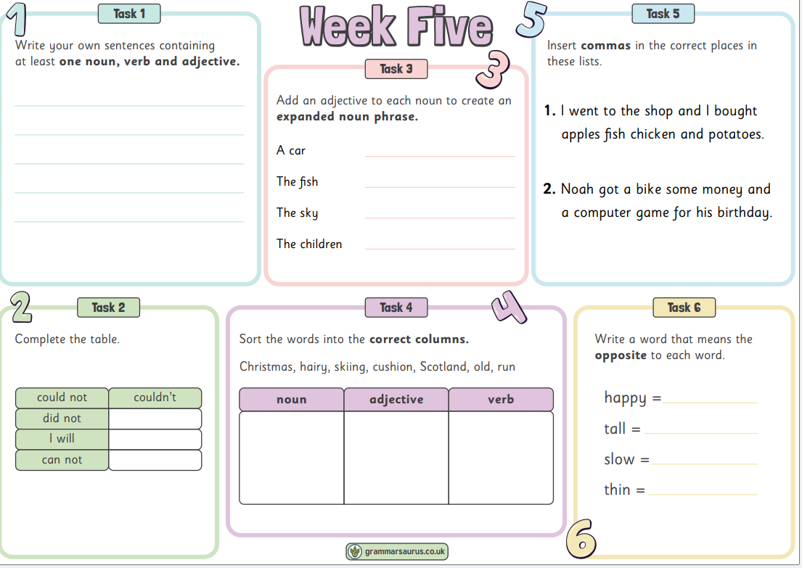

Spellings (Test on Friday 18th)

circle

accidentally

actually

experience

fam**ous**

int**e**rest

minute

occasion

often

often