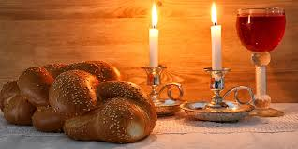

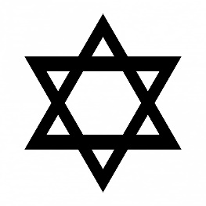
It begins Friday evening and ends on Saturday evening.
Jews stop working and make time for God and family life.
It is the day on which Jews remember the seventh day of creation.
The most important day of the week is Shabbat (the Sabbath).
The family and community are very important within Jewish life.
OUR BIG QUESTION
What makes Shabbat special?

KEY VOCABULARY
creation Shabbat
challah havdalah
Kiddush
JUDAISM – Shabbat
Year 2

