1. | Lent | Lent is a special time in the Christian calendar when people prepare for Easter. It lasts for 40 days and is a time for giving up something you enjoy or doing something extra like helping others, to show love and grow closer to God.
2. | sin | Spoiling our friendship with God through our words or actions to others.
3. | deadly sin | A deadly sin is a very serious wrong choice. These are actions that can really hurt your relationship with God and others, and they need to be fixed with help and prayer.
4. | fasting | Fasting means choosing to give up something for a short time, like food or sweets, to focus more on your faith or to show self-control.
5. | prayer | Prayer is when you talk to God. It’s a way to ask for help, say thank you, or just share your thoughts and feelings with Him.
6. | conscience | Your conscience is like an inner voice that helps you know what is right and wrong. It’s the feeling you get when you’re about to make a good or bad choice.
7. | death | Death is when a person or animal’s body stops working. It’s a part of life.
8. | judgement | Judgement is when God looks at how we lived our lives and decides if we’ll go to heaven or not. It’s about how we treat others and follow His teachings.
9. | heaven | Heaven is a special, beautiful place where people go to be with God after they die, if they’ve lived a good life. It’s a place of peace, happiness, and no pain.
10. | hell | Hell is a place where people go if they’ve made very bad choices and haven’t asked for forgiveness. It’s a place of sadness and separation from God.

Key Vocabulary

1. | Ashes on the Forehead | On Ash Wednesday, Christians go to Mass, where the priest places ashes on their foreheads in the shape of a cross. The ashes come from burning last year’s palm branches from Palm Sunday. This reminds people that life on Earth is temporary and that they need to think about their actions and be sorry for their sins. The priest often says, "Remember that you are dust, and to dust you shall return."
2. | A Day of Fasting and Prayer | • Ash Wednesday is the first day of Lent, a 40-day period where Christians focus on prayer, fasting, and doing good things. Fasting means giving up something like sweets or food to make space for more time to pray and reflect. This is a way of showing that people care more about God than anything else.
3. | Reflect on Sin | The readings at Ash Wednesday Mass often talk about how Christians should admit their sins and ask for God’s forgiveness. It’s a time to reflect on things we might have done wrong and try to be better. Lent is a time to listen to God’s call to return to Him and to change bad habits.
4. | Repentance and Change | Lent is about more than just giving up something; it’s also about changing how you act and trying to be kinder, more generous, and closer to God. Christians might choose to help others, pray more often, or do kind things as a way of answering God’s call and showing that they want to live a better life.
5. | Prayer and Almsgiving | During Lent, Christians remember the importance of prayer, which helps them connect with God. They might pray more during this time, ask for help in their struggles, and try to listen to what God is saying. Almsgiving means giving to people who need help, like donating food or money to the poor. These actions help Christians live out what they hear during the Ash Wednesday Mass and throughout Lent.
Saint Paul
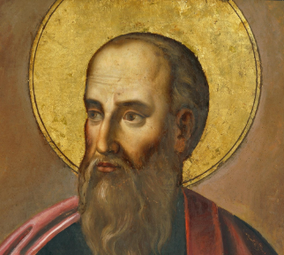 "But thanks be to God!
He gives us the victory through our Lord Jesus Christ."

