**Homework Year 2**

**To be returned by Wed 18th June**

English:

Look at the picture below. Write a setting description for this picture. Remember adjective, adjective, noun. Look at the detail. Describe what you think it might sound like in the room, what would you smell? Who would live here?

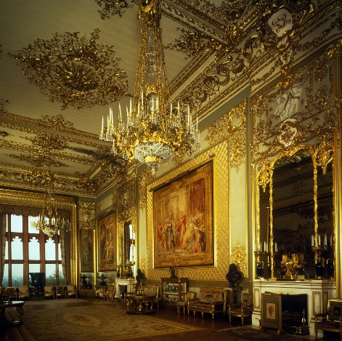

**Maths:**

Design a treasure map using the grid below. Mark your treasure square with a **X** and mark a start square. Give directions of how to reach the treasure. Use turn clockwise, turn anticlockwise, up, down, forward, backward.

Don’t forget to draw some details on your map……maybe there is a shark pool or a jungle…….

See the example attached.

**Spellings**:

Please practice your spellings for a spelling test Friday 20th June.

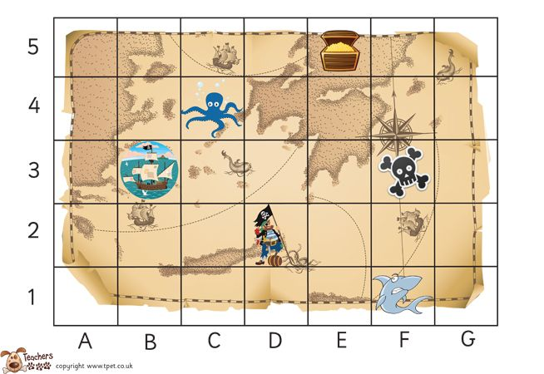

Start in 1A.

Move forward 3 squares to 4A.

Turn a quarter turn clockwise. Move forward 1 square.

Turn a quarter turn anticlockwise.

Move 1 square forward.

Move a quarter turn clockwise.

Move forward 3 squares. You have reached the treasure.

NOW YOUR TURN TO DESIGN A MAP AND WRITE DIRECTIONS:

