Christmas Writing Prompt

The Runaway Christmas Tree

Imagine, you are a beautiful, young Spruce tree standing with your family in a snow-covered forest. The joys of nature are all around you. There is excitement in the air. It is the time of year when one of you get chosen by a family to stand in their house to celebrate the festive season….

You are the ‘chosen one’. You get cut down. Carried to your new home.

Paragraph 1:

How did you feel in the forest with your family? (setting- describe where you were)

How did you feel when you were chosen?

How did you get removed from the forest?

How did you get to your new home?

Paragraph 2:

How did you feel when you were put in a warm house and decorated?

How did you feel when a ‘strangely dressed man in red put presents under you and when the children came down Christmas morning?

Paragraph 3:

After Christmas is over…

You realised you were going to be thrown outside. ( You had heard rumours that sometimes trees were burnt or at best put outside to be shelter for hedgehogs and wildlife etc.)

What did you do then? (How did you escape? Where did you go? Be creative….)

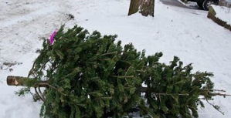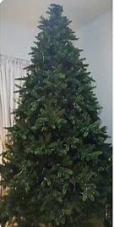Paragraph 1: Paragraph 2: Paragraph 3:

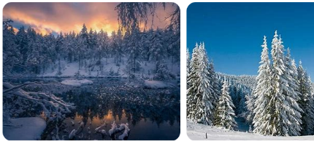

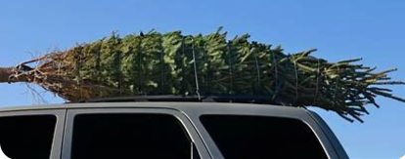

The next morning, I was stripped bare…

I no longer looked beautiful…

At that moment I knew what was going to happen to me…

I had heard rumours in the forest that….

I knew I had to escape….

When I came to, I began to feel the warmth…

My limbs were light and springy…

Before I knew what was happening, people were placing heavy spheres on me….

That night, a strangely dressed man…

In the morning, there was exciting chaos…..

The wind whistled through my branches which were heavy with snow. Birds sang… The air was filled with… It was the day….

Suddenly, the forest echoed with excited voices...